AUBURN PUBLIC CEMETERY DISTRICT
1040 COLLINS DRIVE • P.O. BOX 4357 • AUBURN, CALIFORNIA 95604
(530) 885-5922 • FAX (530) 885-5938

REGULAR BOARD MEETING AGENDA

DATE: June 8th, 2021
TIME: 9:00 A.M.
PLACE: NEW AUBURN CEMETERY - 1040 COLLINS DRIVE -AUBURN, CA. 95603
*Outdoor Social Distancing Meeting.

The Auburn Public Cemetery District is committed to ensuring that persons with disabilities are provided the resources to participate fully in its public meetings. If you are hearing impaired, we have listening devices available. If you require additional disability-related modifications or accommodations, including auxiliary aids or services, please contact the Clerk of the Board. If requested, the agenda shall be provided in appropriate alternative formats to persons with disabilities. All requests must be in writing and must be received by the Clerk five business days prior to scheduled meeting for which you are requesting accommodation. Requests received after such time will be accommodated only if time permits.

- ROLL CALL

- PUBLIC COMMENT – Any person may address (5 minutes maximum) the Board of Trustees on any matter. However, the Board cannot discuss, or take any action on any item that is not on the agenda.

- CONSENT CALENDAR

- Approval of May 11th, 2021, Regular Board Meeting Minutes Page…2
- April 15th, 2021 – May 14th, 2021, Check Register Page...3

- FINANCIAL ITEMS

1. Current Financial Report Pages..4-7
No action to be taken information only.

- MANAGER’S REPORT Pages..8-9

VI. TRUSTEES’ QUESTIONS & COMMENTS

- GOVERNANCE

- CSDA General Manager Leadership Summit – June 28th – 29th Tahoe.
- PCA Seminar – June 16th @ Visalia Cemetery District

- UNFINISHED BUSINESS

None

- NEW BUSINESS

- Block 1 Cremation Garden Pricing – Information/Action Pages..10-11
Consider approval of Block 1 cremation garden pricing.
- CLOSED SESSION

- Public Employee Performance Evaluation –
Title: District Manager – pursuant to Sec. 54957 of the Government Code.

- ADJOURNMENT

This Agenda has been certified and posted in accordance with the Brown Act:

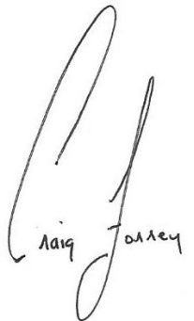 Clerk of the Board.

